

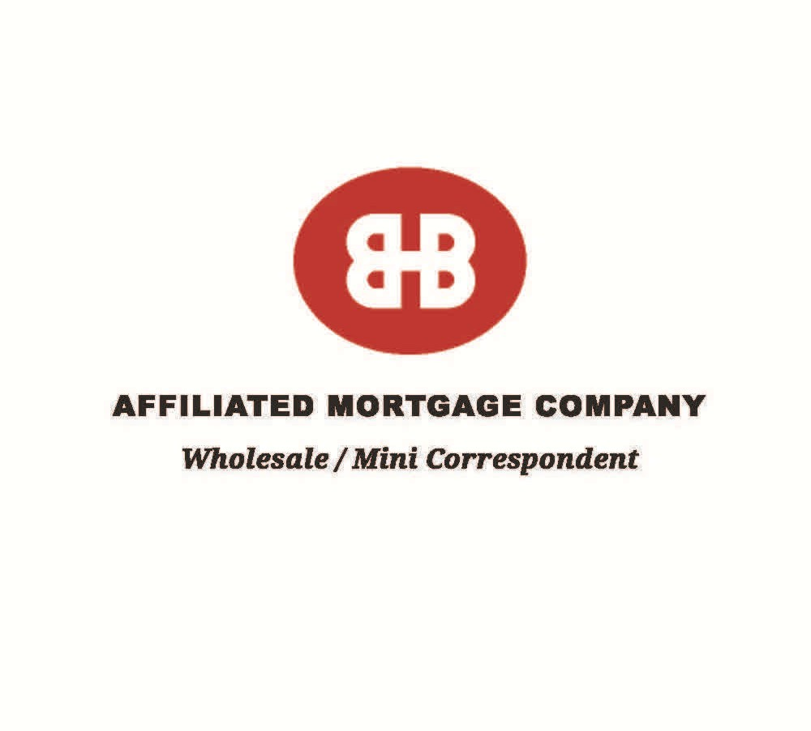

Above and Beyond

WHAT SETS AMC APART

Bank Owned Company Competitive Rates Efficient Loan Process Underwriting to Risk
Experienced In-House Processing, Underwriting and Closing

Full Complement of Loan Products*

See Corresponding Insert

Agency Direct Lender Personalized Customer Service Scenario Help Desks
Prompt Closings

Affiliated Mortgage Company/10700 Richmond Ave. Ste 150/Houston, Texas 77042/713-843-7720

